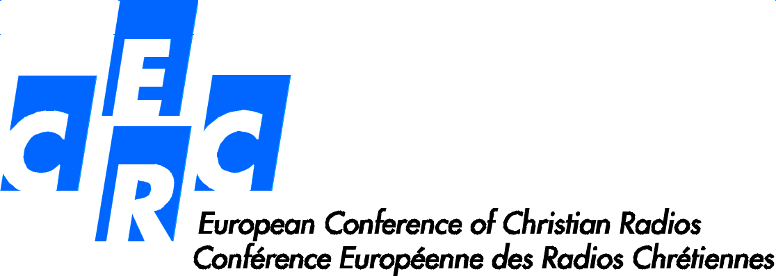
Conference of the ECCR in Brno (Czech Republic)
From October 14 to October 16, 2015

Participants
Austria – Radio Klassik Stephansdom
Stefan HAUSER

Czech Republic – Radio Proglas
P. Martin HOLÍK
Pavel MIKŠŮ
Filip BREINDL
Milan TESAŘ

France – RCF
Emmanuel JOUSSE
Jean-Jacques GARDETTE

Hungary – Szent István Rádió
Ernő TIKOVITS
András BÉRCZESSY

Italy – Corallo
Italo LUNGHI

Netherlands – RKK
Sjoerd MULLER
Christian van der HEIJDEN

Portugal – Radio Renascença
Isabel FIGUEIREDO

Russia – guest of the ECCR
Piotr SAKHAROV

Slovakia – Rádio Lumen
P. Juraj SPUCHĽÁK
Martin ŠAJGALÍK

Slovenia – Radio Ognjišče
Tone Gorjup

Spain – COPE
Enrique Campo GONZALEZ
Álvaro REAL

