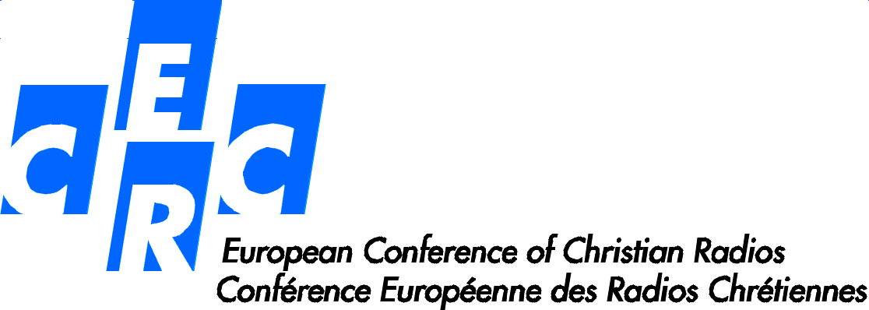

# Meeting of the ECCR

**BRNO, Czech Republic**

**14-16 October 2015**

***“Christian radios and peace in Europe”***

**PROGRAMME**

**Wednesday 14 October 2015**

4:00 pm **Welcome**

6:00 pm **Plenary session**

* Opening speaches by P. Martin Holik, director of the Radio Proglas, and Emmanuel Jousse, president of the CERC

7:00 pm **Presentation of the radios**

8:00 pm **Dinner in hotel**

**Thursday 15 October 2015**

The breakfast is served between 6:30 and 10 am

7:30 am **Mass in the cathedral of Brno**

9:00 am **Presentation of the radios** (continuation)

10:00 am **Coffee Break**

10:30 am **Subjects :**

* The conflict in Ukraine
* The migrants in Europe

12:30 **Lunch**

2:00 pm **Christian radios in Europe and the challenge of the religions**

* Which stakes?
* Which actions for our radios?

3:30 pm **Cultural tour**

* Spilberk Castle
* Radio Proglas

8:00 pm **Dinner**

**Friday 16 October 2015**

The breakfast is served between 6:30 and 10 am

8:00 am **Mass**

9:00 am **Our radios and the music**

* Format
* Leading Line
* Christian music
* Share experiment

10:00 am **The speech of pope Francis to the Council of Europe on November 25 2014**:

* Presentation
* Which stakes for us today?
* Collaboration of the CERC with the Council of Europe

10:30 am **Coffee Break**

11:00 am **General meeting of the CERC**

* Report management
* financial statement
* new members
* common Actions
* Meeting 2016

11:30 am **Concluding plenary session**

1:00 pm **Lunch**